Lab 5 - EtherChannel and Examining STP

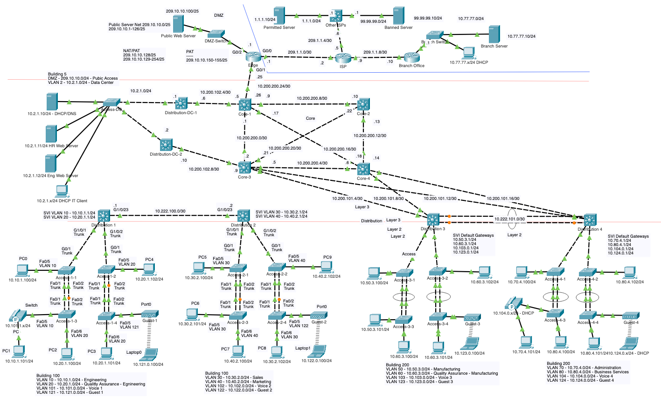

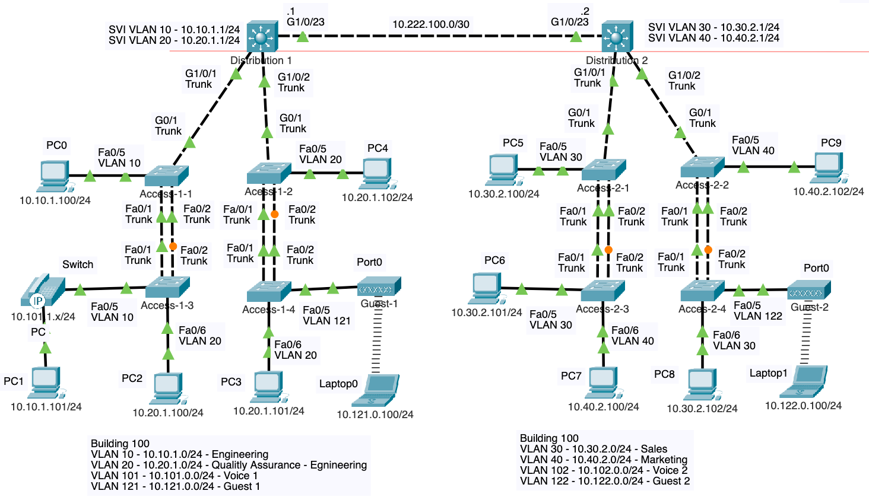

Note: SVIs and routed ports have been configured. Static routes provide reachability between Distribution-1 and Distribution-2 networks.

# Current Topology and Objectives

In the previous lab you configured the SVIs and enabled for the above topology.

The list of objectives covered in this lab:

1. **Understand EtherChannel Concepts**

* Learn how EtherChannel aggregates multiple physical links into a single logical link to improve bandwidth and redundancy.
* Differentiate between Layer 2 and Layer 3 EtherChannel configurations.

1. **Configure Layer 2 EtherChannel Using LACP**

* Configure EtherChannel on access switches using LACP (Link Aggregation Control Protocol).
* Verify EtherChannel formation and status

1. **Examine Spanning Tree Protocol (STP) Before and After EtherChannel**

* Analyze the initial STP state, identifying blocked and forwarding ports.
* Observe how EtherChannel changes STP behavior by allowing both links to forward traffic.

1. **Verify Trunking and VLAN Propagation in EtherChannel**

* Ensure that the port-channel interface properly forwards VLAN traffic.

1. **Configure Layer 3 EtherChannel**

* Convert Layer 2 EtherChannel to Layer 3 by removing switchport functionality.
* Assign an IP address to the Port-channel interface and verify routing functionality.

1. **Verify and Troubleshoot EtherChannel**

* Use commands like **show EtherChannel**, **show spanning-tree**, **show interfaces trunk**, and **ping** to confirm connectivity.
* Troubleshoot common EtherChannel misconfigurations, including mismatched protocols and interface settings.

# EtherChannel

EtherChannel is a port link aggregation technology or protocol developed by Cisco, which allows the bundling of several physical Ethernet links to form a single logical link between two networking devices. This aggregation enhances the bandwidth by combining multiple links' capacities and provides redundancy for higher network resilience.

EtherChannel can operate at both Layer 2 and Layer 3 of the OSI model, enabling flexibility in network design and implementation.

**Link Aggregation Control Protocol (LACP)**: LACP is part of an IEEE standard (802.3ad) that provides a method for automatically creating EtherChannels by dynamically negotiating with connected devices.

**Port Aggregation Protocol (PAgP)**: PAgP is a Cisco proprietary protocol similar to LACP, designed to automatically negotiate the formation of EtherChannel links.

LACP and PAgP facilitate the detection and configuration of links that are capable of aggregation and ensures that only compatible and properly configured links are aggregated. These protocols are highly recommended for its ability to dynamically manage link aggregation, thereby reducing the likelihood of configuration errors and improving network resilience. This facilitates the automatic determination of which links can be combined based on their configurations and ensures consistent configurations on both ends of the EtherChannel. While PAgP offers benefits similar to LACP, its use is limited to Cisco devices.

**Static Persistence (Manual Configuration)**: EtherChannel can also be configured statically, without using LACP or PAgP for negotiation. This method requires manual configuration of both ends of the EtherChannel to aggregate the links. While this approach offers simplicity and control, it lacks the dynamic negotiation and configuration verification features of LACP and PAgP, potentially increasing the risk of misconfiguration and operational issues.

**Note**: In this lab we will be configuring Layer 2 and Layer 3 EtherChannel using LACP.

# Layer 2 EtherChannel

At Layer 2, EtherChannel combines multiple Ethernet links into a single logical link that operates between two switches or between a switch and a server. This configuration is typically used in scenarios where bandwidth aggregation and link redundancy are critical for the operation of access or aggregation layer switches within a data center or campus network.

Layer 2 EtherChannel between two switches allows STP to treat the combined physical links (known as a port channel) as a single logical link. This means all the switchports that are part of the Layer 2 EtherChannel are in the forwarding state.

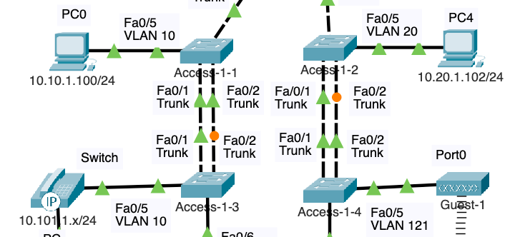

Examine the current configuration of FastEthernet 0/1 and 0/2 ports on any of our access switches, such as Access-1-1.

access-1-1# **show run**

<output omitted for brevity>

!

interface FastEthernet0/1

switchport trunk native vlan 254

switchport trunk allowed vlan 1,10,20,30,40,101-102,121-122,180,254

switchport mode trunk

switchport nonegotiate

!

interface FastEthernet0/2

switchport trunk native vlan 254

switchport trunk allowed vlan 1,10,20,30,40,101-102,121-122,180,254

switchport mode trunk

switchport nonegotiate

!

## Examine Current Spanning-Tree States

Depending on the MAC addresses of your switches, one of your switches (distribution or access) will be the root bridge for all VLANs. In a later lab we will configure the distribution switches to be the STP root bridges.

One of the two access switches will have one its ports in blocking mode (amber link light), preventing the sending and receiving for Ethernet frames for loop prevention.

In the topology shown in this lab, the Access-1-3 switch has its Fa0/2 port in the Blocking state (or Alternate role), as indicated by the amber link light. The Fa0/1 port is the Root port and is in the Forwarding state, as indicated by the green link light. These are actual link lights you will see on the switch. Your topology may differ.

Access-1-1 switch has both Fa0/1 and Fa0/2 in Forwarding state, indicated by the green link lights. Again, your topology may differ. The result is that only one of the two links is being used to forward Ethernet frames. The blocked link will only transition to Forwarding state if the forwarding link fails. This occurs after STP reconverges.

This output represents the current STP state for various ports in our network topology. Each port is marked with its role and status, where "FWD" indicates Forwarding state, meaning the port actively sends and receives traffic, while "BLK" indicates Blocking state, where the port is idle to prevent network loops. For instance, ports in Forwarding state are participating in data transfer, whereas Blocking ports are kept in standby as backup paths. This ensures a loop-free network topology and resilience, as STP will transition a Blocking port to Forwarding if a Forwarding port fails, maintaining connectivity.

access-1-1#**show spanning-tree inter fa 0/1**

Vlan Role Sts Cost Prio.Nbr Type

---------------- ---- --- --------- -------- --------------------------------

VLAN0001 Desg FWD 19 128.1 P2p

VLAN0010 Desg FWD 19 128.1 P2p

VLAN0020 Desg FWD 19 128.1 P2p

VLAN0030 Desg FWD 19 128.1 P2p

VLAN0040 Desg FWD 19 128.1 P2p

<output omitted for brevity>

VLAN0254 Desg FWD 19 128.1 P2p

VLAN0255 19 128.1 P2p

access-1-1#**show spanning-tree inter fa 0/2**

Vlan Role Sts Cost Prio.Nbr Type

---------------- ---- --- --------- -------- --------------------------------

VLAN0001 Desg FWD 19 128.2 P2p

VLAN0010 Desg FWD 19 128.2 P2p

VLAN0020 Desg FWD 19 128.2 P2p

VLAN0030 Desg FWD 19 128.2 P2p

VLAN0040 Desg FWD 19 128.2 P2p

<output omitted for brevity>

VLAN0254 Desg FWD 19 128.2 P2p

VLAN0255 19 128.2 P2p

access-1-1#

access-1-3#**show spanning-tree interface fa 0/1**

Vlan Role Sts Cost Prio.Nbr Type

---------------- ---- --- --------- -------- --------------------------------

VLAN0001 Root FWD 19 128.1 P2p

VLAN0010 Root FWD 19 128.1 P2p

VLAN0020 Root FWD 19 128.1 P2p

VLAN0030 Root FWD 19 128.1 P2p

VLAN0040 Root FWD 19 128.1 P2p

<output omitted for brevity>

VLAN0254 Root FWD 19 128.1 P2p

VLAN0255 19 128.1 P2p

access-1-3#**show spanning-tree interface fa 0/2**

Vlan Role Sts Cost Prio.Nbr Type

---------------- ---- --- --------- -------- --------------------------------

VLAN0001 Altn BLK 19 128.2 P2p

VLAN0010 Altn BLK 19 128.2 P2p

VLAN0020 Altn BLK 19 128.2 P2p

VLAN0030 Altn BLK 19 128.2 P2p

VLAN0040 Altn BLK 19 128.2 P2p

<output omitted for brevity>

VLAN0254 Altn BLK 19 128.2 P2p

VLAN0255 19 128.2 P2p

access-1-3#

## Examine Current Trunk Information

The trunk link consists of two physical interfaces, Fa0/1 and Fa0/2. Remember, because there is a loop, STP is blocking one of the ports on one of the two switches.

access-1-1# **show interfaces trunk**

Port Mode Encapsulation Status Native vlan

Fa0/1 on 802.1q trunking 254

Fa0/2 on 802.1q trunking 254

Gig0/1 on 802.1q trunking 254

Port Vlans allowed on trunk

Fa0/1 1,10,20,30,40,101-102,121-122,180,254

Fa0/2 1,10,20,30,40,101-102,121-122,180,254

Gig0/1 1,10,20,30,40,101-102,121-122,180,254

Port Vlans allowed and active in management domain

Fa0/1 1,10,20,30,40,101,102,121,122,180,254

Fa0/2 1,10,20,30,40,101,102,121,122,180,254

Gig0/1 1,10,20,30,40,101,102,121,122,180,254

Port Vlans in spanning tree forwarding state and not pruned

Fa0/1 1,10,20,30,40,101,102,121,122,180,254

Fa0/2 1,10,20,30,40,101,102,121,122,180,254

Gig0/1 1,10,20,30,40,101,102,121,122,180,254

access-1-1#

# Configure EtherChannel Using LACP

In this section, we will configure EtherChannel using the Link Aggregation Control Protocol (LACP) to bundle two physical links into a single logical port channel. This configuration will allow both links to operate in the Forwarding state simultaneously, increasing available bandwidth and improving redundancy between the two switches.

Starting with the access switches Access-1-1 and Access-1-3, configure these commands on each of the two switches that you want to configure with EtherChannel. This will ensure that both sides of the channel are configured to negotiate the EtherChannel properly and that load balancing is handled in the desired way. Remember, it's essential that both ends of the EtherChannel are configured consistently.

access-1-1(config)# **port-channel load-balance src-dst-ip**

access-1-1(config)# **inter range fa 0/1-2**

access-1-1(config-if-range)# **shutdown**

access-1-1(config-if-range)# **channel-protocol lacp**

access-1-1(config-if-range)# **channel-group 1 mode active**

access-1-3(config)# **port-channel load-balance src-dst-ip**

access-1-3(config)# **inter range fa 0/1-2**

access-1-3(config-if-range)# **shutdown**

access-1-3(config-if-range)# **channel-protocol lacp**

access-1-3(config-if-range)# **channel-group 1 mode active**

Here's a brief explanation of the commands:

* **port-channel load-balance src-dst-ip**: This command configures the load-balancing method for all EtherChannels on the switch to be based on the source and destination IP addresses. When the switch has to decide which port to use to forward a frame, it will take into account the combination of both source and destination IP addresses.
* **interface range fa 0/1-2**: This command is used to enter the interface range configuration mode for FastEthernet ports 0/1 to 0/2. This allows you to configure multiple interfaces with the same configuration commands simultaneously.
  1. **shutdown** (within interface range configuration mode): This command administratively shuts down the interfaces that are currently being configured (in this case, FastEthernet ports 0/1 to 0/2). This is often done before applying certain configuration changes.
  2. **channel-protocol lacp**: This command sets the Link Aggregation Control Protocol (LACP) as the protocol to be used on the specified interfaces for negotiating the EtherChannel with the connected device. LACP is one of the protocols supported by EtherChannel, the other being PAgP (Port Aggregation Protocol), which is Cisco proprietary.
  3. **channel-group 1 mode active**: This command assigns the selected interfaces to channel-group number 1 and sets them to actively negotiate an LACP EtherChannel with the remote switch. 'Active' means that the port will initiate negotiations with the remote switch to form an LACP EtherChannel.

**Note**: To avoid inconsistencies and synchronization issues, it is important to **shutdown** both the interface before configuring EtherChannel. Do not bring up the interface until the other end of the port-channel is either configured or shutdown.

Bring up both interfaces on access-1-1

access-1-1(config)# **inter range fa 0/1-2**

access-1-1(config-if-range)# **no shutdown**

Bring up both interfaces on access-1-3

access-1-3(config)# **inter range fa 0/1-2**

access-1-3(config-if-range)# **no shutdown**

Perform these same commands on all eight access switches. Below is the *copy and paste* version.

**conf t**

**port-channel load-balance src-dst-ip**

**inter range fa 0/1-2**

**shutdown**

**channel-protocol lacp**

**channel-group 1 mode active**

**no shutdown**

**end**

**copy run start**

After several minutes, waiting for STP to re-converge, you will notice that both links between all the access switches have green link lights.

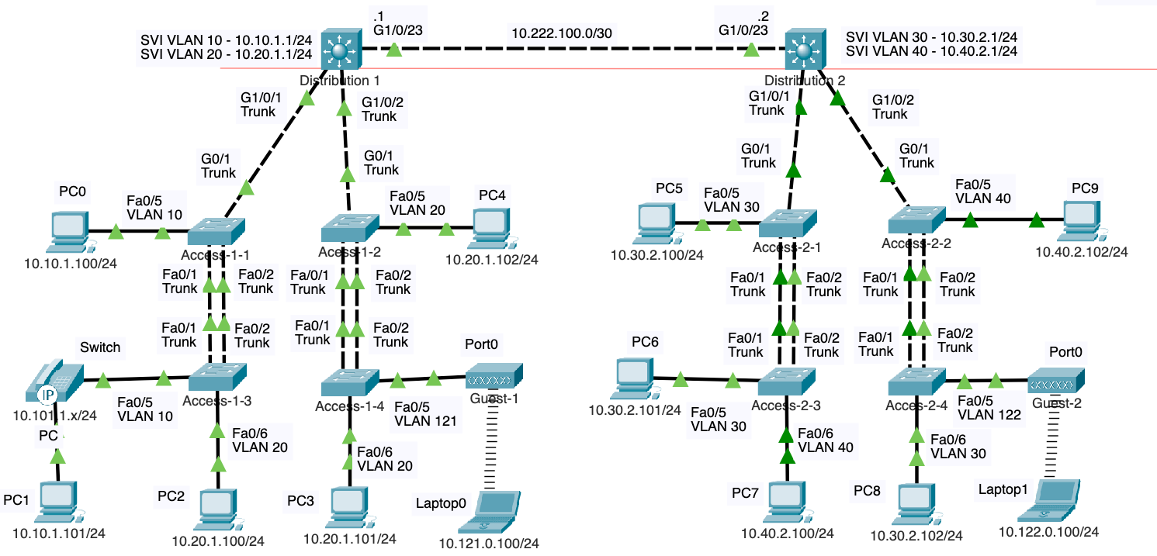

Using the **show running-config** command, examine the new running-config on one of the switches. Notice the new **Port-channel1** interface.

**Packet Tracer Bug:** In Packet Tracker, the Port-channel1 interface does not inherit the **switchport trunk allowed vlan** command from the physical interface. You will notice this when you issue the **show running-config command**. This will give you incorrect output when issuing commands such as **show running-config**, and **show interfaces trunk**.

access-1-1# **show running-config**

!

<output omitted for brevity>

!

interface Port-channel1

switchport trunk native vlan 254

switchport trunk allowed vlan 1,10,20,30,40,101-102,121-122,180,254

switchport mode trunk

switchport nonegotiate

!

interface FastEthernet0/1

switchport trunk native vlan 254

switchport trunk allowed vlan 1,10,20,30,40,101-102,121-122,180,254

switchport mode trunk

switchport nonegotiate

channel-protocol lacp

channel-group 1 mode active

!

interface FastEthernet0/2

switchport trunk native vlan 254

switchport trunk allowed vlan 1,10,20,30,40,101-102,121-122,180,254

switchport mode trunk

switchport nonegotiate

channel-protocol lacp

!

access-1-1#**show interfaces trunk**

Port Mode Encapsulation Status Native vlan

Po1 on 802.1q trunking 254

Gig0/1 on 802.1q trunking 254

Port Vlans allowed on trunk

Po1 1-1005

Gig0/1 1,10,20,30,40,101-102,121-122,180,254

**On all access switches**, configure the **switchport trunk allowed vlan** command to the **port-channel** interface:

access-1-1(config)# **interface po1**

access-1-1(config-if)# **switchport trunk allowed vlan 1,10,20,30,40,101-102,121-122,180,254**

access-1-1(config-if)# **end**

access-1-1# **show interfaces trunk**

Port Mode Encapsulation Status Native vlan

Po1 on 802.1q trunking 254

Gig0/1 on 802.1q trunking 254

Port Vlans allowed on trunk

Po1 1,10,20,30,40,101-102,121-122,180,254

Gig0/1 1,10,20,30,40,101-102,121-122,180,254

access-1-3(config)# **interface po1**

access-1-3(config-if)# **switchport trunk allowed vlan 1,10,20,30,40,101-102,121-122,180,254**

Repeat this command on all access layer switches (8 switches) configured for EtherChannel.

**conf t**

**inter po1**

**switchport trunk allowed vlan 1,10,20,30,40,101-102,121-122,180,254**

**end**

**copy run start**

Verify with **show running-config** and **show interfaces trunk**

The new **Port-channel1** interface is a logical interface on the Cisco switch that represents the EtherChannel itself. EtherChannel aggregates the individual physical links (in this case, FastEthernet0/1 and FastEthernet0/2) into a single logical link, which increases bandwidth and provides redundancy.

The **Port-channel1** interface received these commands, when you use the **channel-group** command on physical interfaces and associate them with a channel-group, the Cisco IOS software automatically creates the corresponding port-channel interface if it does not already exist. The configuration commands applied to the physical interfaces that are members of the channel-group are replicated to the port-channel interface. Thus, it inherits the configuration of its member ports. If the port-channel already exists, the physical interface's configuration must match the port-channel's configuration for the EtherChannel to work correctly.

This means that the **Port-channel1** interface now represents the aggregation of FastEthernet0/1 and FastEthernet0/2, and any configuration applied to **Port-channel1** applies to the traffic across both physical links in the EtherChannel.

**Note**: With very few exceptions, changes to the EtherChannel configuration (whether a negotiation protocol is used or not) must be made at the port-channel level. This includes and VLAN or trunking commands such as changing the Native VLAN. Changes you make directly to the member interfaces of a port-channel may create synchronization issues that will cause the group to fail or underperform.

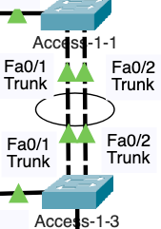

It is common to represent a port channel in a topology diagram with an oval over the links in the port channel.

### Re-Examining Spanning-Tree after EtherChannel Configuration

Before configuring EtherChannel, Spanning Tree blocked one of the two ports on one of the ends of the two switches. In my topology, Access-1-3, Fa0/2 was a blocked port. When we re-examine spanning-tree on that port, notice that it is now in forwarding state.

access-1-3#**show spanning-tree interface fa 0/2**

Vlan Role Sts Cost Prio.Nbr Type

---------------- ---- --- --------- -------- --------------------------------

VLAN0001 Desg FWD 19 128.2 P2p

VLAN0010 Desg FWD 19 128.2 P2p

VLAN0020 Desg FWD 19 128.2 P2p

VLAN0030 Desg FWD 19 128.2 P2p

VLAN0040 Desg FWD 19 128.2 P2p

VLAN0101 Desg FWD 19 128.2 P2p

VLAN0102 Desg FWD 19 128.2 P2p

VLAN0121 Desg FWD 19 128.2 P2p

VLAN0122 Desg FWD 19 128.2 P2p

VLAN0180 Desg FWD 19 128.2 P2p

VLAN0254 Desg FWD 19 128.2 P2p

VLAN0255 FWD 19 128.2 P2p

access-1-3#

**After configuring EtherChannel**, Spanning Tree Protocol (STP) now treats the previously individual FastEthernet0/1 and FastEthernet0/2 ports as a single logical link, known as Port-channel1. As a result, STP no longer needs to block one of the ports to prevent potential loops, because the aggregation technology ensures that the combined physical links operate as a unified connection.

This single logical path is managed by STP as if it were a single port, which means all the ports within the EtherChannel bundle are placed in a forwarding state, enhancing bandwidth utilization and redundancy without the risk of broadcast storms or loops that STP is designed to prevent. This unified behavior is key to EtherChannel's effectiveness, as it allows for both ports on each switch to actively forward traffic, doubling the link capacity while maintaining a loop-free network topology.

The command **show spanning-tree interface port-channel 1** would display the Spanning Tree Protocol (STP) status and information specifically for the Port-channel 1 interface, which represents the aggregated EtherChannel. In the context of Layer 2 (L2) EtherChannel, **Po1** logically bundles the member physical ports together, such as FastEthernet0/1 and FastEthernet0/2, allowing them to be treated as a single STP entity.

access-1-3# **show spanning-tree interface port-channel 1**

Vlan Role Sts Cost Prio.Nbr Type

---------------- ---- --- --------- -------- --------------------------------

VLAN0001 Root FWD 12 128.27 Shr

VLAN0010 Root FWD 12 128.27 Shr

VLAN0020 Root FWD 12 128.27 Shr

VLAN0030 Root FWD 12 128.27 Shr

VLAN0040 Root FWD 12 128.27 Shr

VLAN0101 Root FWD 12 128.27 Shr

VLAN0102 Root FWD 12 128.27 Shr

VLAN0121 Root FWD 12 128.27 Shr

VLAN0122 Root FWD 12 128.27 Shr

VLAN0180 Root FWD 12 128.27 Shr

VLAN0254 Root FWD 12 128.27 Shr

VLAN0255 Desg FWD 12 128.27 Shr

access-1-3#

# Verifying Layer 2 EtherChannel

## Verify L2 EtherChannel with show etherchannel

The **show etherchannel** command on a Cisco switch provides information about the EtherChannel configuration and status.

access-1-1# **show etherchannel**

Channel-group listing:

----------------------

Group: 1

----------

Group state = L2

Ports: 2 Maxports = 16

Port-channels: 1 Max Port-channels = 16

Protocol: LACP

access-1-1#

Here is a brief explanation of the output provided by the command, **show etherchannel**:

* **Group: 1**: This indicates the EtherChannel group number, which is a numeric identifier for the specific EtherChannel. You can have multiple EtherChannels on a switch, and they would be distinguished by their group numbers.
* **Group state = L2**: This shows that the EtherChannel is operating as a Layer 2 link (at the data link layer), which means it's functioning as a switchport and can carry VLAN traffic.
* **Ports: 2 Maxports = 16**: This indicates that there are currently 2 physical ports (interfaces) bundled into this EtherChannel group. The maximum number of ports that could be bundled in this EtherChannel (or any EtherChannel on this switch) is 16.
* **Port-channels: 1 Max Port-channels = 16**: This tells you that there's currently 1 logical Port-channel interface formed from the bundled ports. The switch can have up to 16 such Port-channel interfaces.
* **Protocol: LACP**: Indicates that the Link Aggregation Control Protocol (LACP) is the protocol being used for this EtherChannel. LACP is a negotiation protocol that allows the automatic bundling of links by exchanging packets between the switches involved in the EtherChannel.

The **show etherchannel** command output is helpful for verifying the number of ports in a channel, understanding what state the channel group is in (Layer 2 or Layer 3), checking the protocol used (LACP or PAgP if it's Cisco proprietary), and for troubleshooting purposes to ensure that the EtherChannel is operating as expected.

## Verify L2 EtherChannel with show etherchannel summary

The **show etherchannel summary** command provides a concise overview of the EtherChannel configuration on the Cisco switch.

access-1-1# **show etherchannel summary**

Flags: D - down P - in port-channel

I - stand-alone s - suspended

H - Hot-standby (LACP only)

R - Layer3 S - Layer2

U - in use f - failed to allocate aggregator

u - unsuitable for bundling

w - waiting to be aggregated

d - default port

Number of channel-groups in use: 1

Number of aggregators: 1

Group Port-channel Protocol Ports

------+-------------+-----------+----------------------------------------------

1 Po1(SU) LACP Fa0/1(P) Fa0/2(P)

access-1-1#

Here is a brief explanation of the output provided by the command, **show etherchannel summary:**

* **Flags**: This part explains the meaning of various single-letter flags that can appear next to the ports in the summary:
  + **P** indicates that the port is part of a port-channel.
  + **S** indicates that the port is operating at Layer 2.
  + **U** means the port is currently in use.
* **Number of channel-groups in use**: This shows how many EtherChannel groups are active on the switch. Here it's 1, which means there's only one EtherChannel configured and in use.
* **Number of aggregators**: This is the number of logical port-channel interfaces or aggregators created from the EtherChannel groups. Again, it's 1, meaning there is one Port-channel interface corresponding to the single EtherChannel group.
* **Group Port-channel Protocol Ports**:
  + **1**: The number here represents the EtherChannel group number.
  + **Po1(SU)**: **Po1** is the name of the Port-channel interface. The flags **(SU)** mean that this Port-channel is operating at Layer 2 (**S**) and is currently in use (**U**).
  + **LACP**: This is the protocol in use for the EtherChannel. LACP is a standard protocol that enables the automatic creation of EtherChannels by exchanging packets between the ports of the involved switches.
  + **Fa0/1(P) Fa0/2(P)**: The ports listed are the members of the EtherChannel. **Fa0/1** and **Fa0/2** are both part of the Port-channel (**P**), meaning they are both active in the EtherChannel and are forwarding traffic.

This summary is quite useful for quickly verifying the status and configuration of EtherChannels. In this particular output, you can see that both FastEthernet ports 0/1 and 0/2 are bundled together in a single Port-channel interface using LACP, both are active and in use, and the logical link is operating as a Layer 2 interface.

## Verify L2 EtherChannel with show etherchannel port-channel

The **show etherchannel port-channel** command provides detailed information about the specified EtherChannel group and its member ports.

access-1-1# **show etherchannel port-channel**

Channel-group listing:

----------------------

Group: 1

----------

Port-channels in the group:

---------------------------

Port-channel: Po1 (Primary Aggregator)

------------

Age of the Port-channel = 00d:00h:24m:52s

Logical slot/port = 2/1 Number of ports = 2

GC = 0x00000000 HotStandBy port = null

Port state = Port-channel

Protocol = LACP

Port Security = Disabled

Ports in the Port-channel:

Index Load Port EC state No of bits

------+------+------+------------------+-----------

0 00 Fa0/1 Active 0

0 00 Fa0/2 Active 0

Time since last port bundled: 00d:00h:23m:17s Fa0/2

access-1-1#

Here is a brief explanation of the output provided by the command, **show etherchannel port-channel**:

* **Port-channel: Po1 (Primary Aggregator)**: This indicates that Port-channel 1 (Po1) is the primary aggregator, which means it is the logical interface representing the EtherChannel.
* **Age of the Port-channel**: This shows how long the Port-channel has been up and running. In this case, it has been up for 6 minutes and 28 seconds.
* **Logical slot/port = 2/1 Number of ports = 2**: This provides the virtual slot and port number of the Port-channel and indicates that there are 2 physical ports bundled into this Port-channel.
* **Port state = Port-channel**: The state of the port-channel indicates that it is active and functioning as a combined Port-channel.
* **Protocol = LACP**: This confirms that the Link Aggregation Control Protocol (LACP) is the protocol used to form this EtherChannel.
* **Port Security = Disabled**: Port security, which can restrict input to an interface by limiting and identifying MAC addresses of the workstations allowed to access the port, is turned off for this Port-channel.
* **Ports in the Port-channel**: This section lists the individual ports that are members of the Port-channel.
* **Index Load Port EC state No of bits**: This header introduces the columns below, which list the member ports and their state.
  + **Fa0/2** and **Fa0/1** are listed with an EC state of **Active**, meaning they are actively participating in the EtherChannel and are forwarding traffic.
  + **Load** refers to load-balancing and since it's **00**, it could indicate that either load-balancing is equally distributed or not specifically configured.
  + **No of bits** likely refers to how the load-balancing algorithm is applied, which in this case shows **0**, indicating no special bit-level manipulation in load-distribution decisions.
* **Time since last port bundled:**: This indicates the time elapsed since the last port (in this case, FastEthernet0/1) was added to the EtherChannel.

Overall, this output is useful for verifying the status and configuration of individual ports within an EtherChannel, ensuring they're all active and participating in load-balancing traffic across the Port-channel.

## Verify L2 EtherChannel with show etherchannel load-balance

The **show etherchannel load-balance** command displays the current load-balancing method that the switch is using for EtherChannel. This method determines how the switch distributes frames over the EtherChannel member links.

access-1-1# **show etherchannel load-balance**

EtherChannel Load-Balancing Operational State (src-dst-ip):

Non-IP: Source XOR Destination MAC address

IPv4: Source XOR Destination IP address

IPv6: Source XOR Destination IP address

access-1-1#

Here is a brief explanation of the output provided by the command, **show etherchannel load-balance**:

* **EtherChannel Load-Balancing Operational State (src-dst-ip)**: Indicates the operational state of load-balancing for EtherChannel and specifies the algorithm being used, which in this case is based on the combination of source and destination IP addresses (**src-dst-ip**).
* **Non-IP: Source XOR Destination MAC address**: For non-IP traffic, the switch uses an exclusive OR (XOR) operation on the source and destination MAC addresses to determine which port to use for forwarding frames. This helps distribute non-IP traffic across the available links in the EtherChannel evenly.
* **IPv4: Source XOR Destination IP address**: For IPv4 traffic, the switch performs an XOR operation on the source and destination IP addresses to spread the traffic across the member links.
* **IPv6: Source XOR Destination IP address**: Similarly, for IPv6 traffic, the switch also uses an XOR of the source and destination IP addresses for load distribution.

This load-balancing approach aims to evenly distribute traffic over the EtherChannel links to prevent any single link from becoming a bottleneck, thus making efficient use of the aggregated bandwidth. The XOR operation provides a simple way to achieve a balanced distribution for a wide variety of traffic patterns.

# Layer 3 EtherChannel - LACP

Layer 3 EtherChannel is an aggregates multiple physical links between two Layer 3 devices—such as routers or Layer 3 switches—into a single logical link that operates at the network layer. By assigning an IP address to the combined Port-channel interface, this EtherChannel can route packets and participate in IP-based routing protocols, enhancing both the bandwidth and redundancy of the connection. It's ideal for critical high-speed links that carry substantial inter-VLAN traffic or for connecting core network infrastructure, ensuring consistent high availability and load balancing across multiple physical paths, making the network more resilient to individual link failures.

A look at our current routed interface between Distribution-1 and Distribution-2.



distribution-1#**show ip interface brief**

Interface IP-Address OK? Method Status Protocol

GigabitEthernet1/0/1 unassigned YES unset up up

<output omitted for brevity>

GigabitEthernet1/0/22 unassigned YES unset down down

GigabitEthernet1/0/23 10.222.100.1 YES manual up up

GigabitEthernet1/0/24 unassigned YES unset down down

GigabitEthernet1/1/1 unassigned YES unset down down

GigabitEthernet1/1/2 unassigned YES unset down down

GigabitEthernet1/1/3 unassigned YES unset down down

GigabitEthernet1/1/4 unassigned YES unset down down

Vlan1 unassigned YES unset administratively down down

Vlan10 10.10.1.1 YES manual up up

Vlan20 10.20.1.1 YES manual up up

distribution-1#**show ip route**

Codes: C - connected, S - static, I - IGRP, R - RIP, M - mobile, B - BGP

D - EIGRP, EX - EIGRP external, O - OSPF, IA - OSPF inter area

N1 - OSPF NSSA external type 1, N2 - OSPF NSSA external type 2

E1 - OSPF external type 1, E2 - OSPF external type 2, E - EGP

i - IS-IS, L1 - IS-IS level-1, L2 - IS-IS level-2, ia - IS-IS inter area

* - candidate default, U - per-user static route, o - ODR

P - periodic downloaded static route

Gateway of last resort is not set

10.0.0.0/8 is variably subnetted, 5 subnets, 2 masks

C 10.10.1.0/24 is directly connected, Vlan10

C 10.20.1.0/24 is directly connected, Vlan20

S 10.30.2.0/24 [1/0] via 10.222.100.2

S 10.40.2.0/24 [1/0] via 10.222.100.2

C 10.222.100.0/30 is directly connected, GigabitEthernet1/0/23

distribution-1#

## Add a Second Routed Port between Distribution Switches

First, **shutdown** the both ports, on both switches, GigabitEthernet 1/0/23 and 1/0/24. Although not required, it is sometimes best to shutdown ports before aggregating the ports into a port channel to avoid any inconsistencies that may arise.

distribution-1(config)# **interface range g 1/0/23-24**

distribution-1(config-if-range)# **shutdown**

distribution-2(config)# **interface range g 1/0/23-24**

distribution-2(config-if-range)# **shutdown**

Add another physical connection between distribution-1 and distribution-2 using the GigabitEthernet 1/0/24 ports.

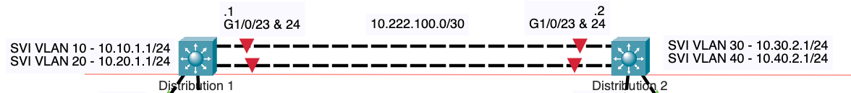

Configure Distribution-1 switch.

distribution-1(config)# **inter g 1/0/23**

distribution-1(config-if)# **no ip address**

distribution-1(config-if)# **exit**

distribution-1(config)# **interface Port-channel2**

distribution-1(config-if)# **no switchport**

distribution-1(config-if)# **ip address 10.222.100.1 255.255.255.252**

distribution-1(config-if)# **no shutdown**

distribution-1(config-if)# **exit**

distribution-1(config)# **interface range gig 1/0/23-24**

distribution-1(config-if-range)# **no switchport**

distribution-1(config-if-range)# **channel-protocol lacp**

distribution-1(config-if-range)# **channel-group 2 mode active**

distribution-1(config-if-range)#

Similar to Distribution-1, configure Distribution-2 switch.

distribution-2(config)# **inter g 1/0/23**

distribution-2(config-if)# **no ip address**

distribution-2(config-if)# **exit**

distribution-2(config)# **interface Port-channel2**

distribution-2(config-if)# **no switchport**

distribution-2(config-if)# **ip address 10.222.100.2 255.255.255.252**

distribution-2(config-if)# **no shutdown**

distribution-2(config-if)# **exit**

distribution-2(config)# **interface range gig 1/0/23-24**

distribution-2(config-if-range)# **no switchport**

distribution-2(config-if-range)# **channel-protocol lacp**

distribution-2(config-if-range)# **channel-group 2 mode active**

distribution-2(config-if-range)#

Using Distribution-1, here's the step-by-step explanation:

* **interface g 1/0/23**:
  1. **no ip address**: Removes any existing IP address from the interface, ensuring it's not treated as a standalone Layer 3 interface.
  2. **exit**: Exits from the interface configuration mode back to the global configuration mode.
* **interface Port-channel2**: Enters the configuration mode for the logical Port-channel2, which will represent the EtherChannel.
  1. **no switchport**: Converts the logical Port-channel2 from a Layer 2 interface (switchport) to a Layer 3 interface (routed port).
  2. **ip address 10.222.100.1 255.255.255.252**: Assigns an IP address and subnet mask to Port-channel2, enabling it to route packets.
  3. **no shutdown**: Enables the Port-channel1, changing its state to up.
* **interface range gig 1/0/23-24**: Selects a range of interfaces, in this case, GigabitEthernet 1/0/23 to 1/0/24, to be configured next.
  1. **no switchport**: Changes the selected physical interfaces from Layer 2 switchports to Layer 3 interfaces, preparing them to be part of a Layer 3 EtherChannel.
  2. **channel-group 2 mode active**: Adds the selected interfaces to channel-group 2 and sets them to actively negotiate an EtherChannel using the LACP protocol.

The configuration sets up a Layer 3 EtherChannel using LACP for dynamic negotiation. The GigabitEthernet interfaces 1/0/23 and 1/0/24 are bundled into a single logical interface (Port-channel2) that can route IP traffic with the address 10.222.100.1/30. This configuration is often used for high-availability, high-bandwidth interconnections between important network devices, like core and distribution layer switches, or between switches and routers.

Enable both physical ports on both Distribution switches to bring up the port channel.

distribution-1(config)# **interface range gig 1/0/23-24**

distribution-1(config-if-range)# **no shutdown**

distribution-2(config)# **interface range gig 1/0/23-24**

distribution-2(config-if-range)# **no shutdown**

**Packet Tracer bug:** The link lights will display as amber instead of green.

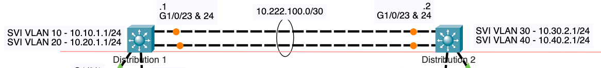

## Changes to the Port-Channel

After you have configured a Layer 3 EtherChannel, any configuration changes related to the IP address or Layer 3 behavior should be made on the Port-channel interface, not on the individual member interfaces. The Port-channel interface is the logical interface that represents the aggregated link, and changes to this interface affect all member ports.

For instance, if you need to change the IP address, update the routing protocol configuration, or adjust other Layer 3 parameters, you should apply these changes to the Port-channel interface. This ensures that the EtherChannel behaves consistently as a single unit. Member interfaces should only be configured for their participation in the EtherChannel (e.g., with the **channel-group** command), and not for Layer 3 parameters, which are centralized at the Port-channel interface.

Verifying Layer 3 EtherChannel

## Verify L3 EtherChannel with show etherchannel

The **show etherchannel** command displays similar to the output using the same command previously for Layer 2 EtherChannel, notice the difference with Layer 3 EtherChannel.

distribution-1#**show etherchannel**

Channel-group listing:

----------------------

Group: 2

----------

Group state = L3

Ports: 2 Maxports = 16

Port-channels: 1 Max Port-channels = 16

Protocol: LACP

distribution-1#

**Group state = L3**: The **L3** state means that this EtherChannel is configured for Layer 3 operations, which differs from a Layer 2 EtherChannel. Layer 3 EtherChannels can have IP addresses assigned and participate in routing, whereas Layer 2 EtherChannels are used for switching purposes and do not have IP addresses.

In contrast to a Layer 2 EtherChannel where the **Group state** would be **L2**, this Layer 3 EtherChannel is capable of routing and requires that the member interfaces are configured with **no switchport** to operate as routed ports rather than switchports. This enables the logical Port-channel to have an IP address and function as a router interface, allowing it to forward IP packets and use routing protocols.

## Verify L3 EtherChannel with show etherchannel summary

The **show etherchannel** summary command is similar to that for layer 2 EtherChannel.

distribution-1#**show etherchannel summary**

Flags: D - down P - in port-channel

I - stand-alone s - suspended

H - Hot-standby (LACP only)

R - Layer3 S - Layer2

U - in use f - failed to allocate aggregator

u - unsuitable for bundling

w - waiting to be aggregated

d - default port

Number of channel-groups in use: 1

Number of aggregators: 1

Group Port-channel Protocol Ports

------+-------------+-----------+----------------------------------------------

2 Po2(RU) LACP Gig1/0/23(P) Gig1/0/24(P)

distribution-1#

The key distinction here between Layer 3 and Layer 2 EtherChannel configurations is indicated by the **R** flag next to **Po1**. In a Layer 2 EtherChannel, you would see an **S** instead.

Layer 3 EtherChannel interfaces act as routed ports and are typically used to connect different subnets and enable routing between them, while Layer 2 EtherChannels operate within the same VLAN and are used to increase bandwidth and provide redundancy on switching paths.

## Verify L3 EtherChannel with show ip interface brief

The **show ip interface brief** command now indicates the IPv4 address is no longer assigned to the physical interface GigabitEthernet 1/0/24, but is now assigned to the port-channel.

distribution-1#**show ip interface brief**

Interface IP-Address OK? Method Status Protocol

Port-channel2 10.222.100.1 YES manual up up

GigabitEthernet1/0/1 unassigned YES unset up up

GigabitEthernet1/0/2 unassigned YES unset up up

<output omitted for brevity>

GigabitEthernet1/0/21 unassigned YES unset down down

GigabitEthernet1/0/22 unassigned YES unset down down

GigabitEthernet1/0/23 unassigned YES manual up up

GigabitEthernet1/0/24 unassigned YES unset up up

GigabitEthernet1/1/1 unassigned YES unset down down

GigabitEthernet1/1/2 unassigned YES unset down down

GigabitEthernet1/1/3 unassigned YES unset down down

GigabitEthernet1/1/4 unassigned YES unset down down

Vlan1 unassigned YES unset administratively down down

Vlan10 10.10.1.1 YES manual up up

Vlan20 10.20.1.1 YES manual up up

distribution-1#

This is because, in a Layer 3 EtherChannel, the IP address is assigned to the logical Port-channel interface, not to the individual physical interfaces. The physical interfaces act as the underlying support for the Port-channel, which handles the routing and Layer 3 traffic.

## Verify L3 EtherChannel with show ip route

The **show ip route** command verifies that the network **10.111.1.0/30** is directly connected to the router via the **Port-channel1** interface. This entry shows that the **Port-channel1** is being used as a routed interface instead of the physical interface G 1/0/23 prior to the port channel configuration. The port channel is used to route traffic for and via the **10.111.1.0/30** network.

distribution-1#**show ip route**

Codes: C - connected, S - static, I - IGRP, R - RIP, M - mobile, B - BGP

D - EIGRP, EX - EIGRP external, O - OSPF, IA - OSPF inter area

N1 - OSPF NSSA external type 1, N2 - OSPF NSSA external type 2

E1 - OSPF external type 1, E2 - OSPF external type 2, E - EGP

i - IS-IS, L1 - IS-IS level-1, L2 - IS-IS level-2, ia - IS-IS inter area

* - candidate default, U - per-user static route, o - ODR

P - periodic downloaded static route

Gateway of last resort is not set

10.0.0.0/8 is variably subnetted, 5 subnets, 2 masks

C 10.10.1.0/24 is directly connected, Vlan10

C 10.20.1.0/24 is directly connected, Vlan20

S 10.30.2.0/24 [1/0] via 10.222.100.2

S 10.40.2.0/24 [1/0] via 10.222.100.2

C 10.222.100.0/30 is directly connected, Port-channel2

distribution-1#

The running-config now shows the IP address belonging to the port channel instead of a physical interface. The physical interfaces are members of port channel 2, which has that IP address.

distribution-1#**show running-config**

<output omitted for brevity>

!

interface Port-channel2

no switchport

ip address 10.222.100.1 255.255.255.252

!

!

interface GigabitEthernet1/0/23

no switchport

no ip address

channel-group 2 mode active

duplex auto

speed auto

!

interface GigabitEthernet1/0/24

no switchport

no ip address

channel-group 2 mode active

duplex auto

speed auto

!

## Verify L3 EtherChannel with ping

The final verification that everything works is using **ping** to verify our Layer2 and Layer 3 EtherChannels are operating as expected.

From PC2 with IPv4 address 10.20.1.100, ping PC8 10.30.2.102. This frame/packet will need to be forwarded across both Layer 2 and Layer 3 EtherChannels.

C:\>**ping 10.30.2.102**

Pinging 10.30.2.102 with 32 bytes of data:

Request timed out.

Request timed out.

Reply from 10.30.2.102: bytes=32 time<1ms TTL=126

Reply from 10.30.2.102: bytes=32 time<1ms TTL=126

Ping statistics for 10.30.2.102:

Packets: Sent = 4, Received = 2, Lost = 2 (50% loss),

Approximate round trip times in milli-seconds:

Minimum = 0ms, Maximum = 0ms, Average = 0ms

C:\>**ping 10.30.2.102**

Pinging 10.30.2.102 with 32 bytes of data:

Reply from 10.30.2.102: bytes=32 time<1ms TTL=126

Reply from 10.30.2.102: bytes=32 time=3ms TTL=126

Reply from 10.30.2.102: bytes=32 time<1ms TTL=126

Reply from 10.30.2.102: bytes=32 time<1ms TTL=126

Ping statistics for 10.30.2.102:

Packets: Sent = 4, Received = 4, Lost = 0 (0% loss),

Approximate round trip times in milli-seconds:

Minimum = 0ms, Maximum = 3ms, Average = 0ms

C:\>